|  |  |  |
| --- | --- | --- |
|  |  | |
| C:\Users\kperrin\Desktop\Projectwise Extracts\May 2016\P1020351.JPG |  | **Alexandria Arlington**  **Resource Recovery Facility**  Fiscal Year 2016  Annual Operations Report  **August 2016** |
| C:\Users\kperrin\Desktop\Projectwise Extracts\May 2016\P1020364.JPG |  |
| **Prepared by:**  **HDR Engineering, Inc.**  **5426 Bay Center Drive, Suite 400**  **Tampa, Florida 33609-3444** | C:\Users\kperrin\Desktop\Projectwise Extracts\May 2016\P1020357.JPG | |
|  |  | |

Table of Contents

Section No. Page No.

1.0 Purpose of Report 4

2.0 Executive Summary 4

3.0 Facility Inspection and Records Review 6

4.0 Facility Performance 11

4.1 Utility and Reagent Consumptions 27

4.2 Safety & Environmental Training 28

5.0 Facility Maintenance 29

5.1 Availability 29

5.2 Downtime Summary 31

5.3 Facility Housekeeping 32

6.0 Environmental 33

6.1 Nitrogen Oxide Emissions 33

6.2 Sulfur Dioxide Emissions 33

6.3 Carbon Monoxide Emissions 33

6.4 Opacity 34

6.5 Daily Emissions Data 34

6.6 2016 Annual Stack Testing 34

6.7 Ash System Compliance 37

APPENDIX A FACILITY CEMS DATA 38

APPENDIX B PHOTOS 42

List of Tables

Table No. Page No.

Table 1: Summary of Audit Report Deficiencies 8

Table 2: Quarterly Performance Summaries 19

Table 3: Waste Delivery Classification 20

Table 4: Facility Utility and Reagent Consumptions 27

Table 5: Quarterly Facility Unit Availabilities 30

Table 6: Boiler Downtime – Q4FY16 31

Table 7: Turbine Generator Downtime – Q4FY16 31

Table 8: Facility Housekeeping Ratings – May 2016 32

Table 9: Stack Test Results through 2016 36

Table 10: Unit #1 Monthly Summary for Reportable Emissions Data 39

Table 11: Unit #2 Monthly Summary for Reportable Emissions Data 40

Table 12: Unit #3 Monthly Summary for Reportable Emissions Data 41

List of Charts

Chart No. Page No.

Chart 1: Tons of Waste Processed 12

Chart 2: Tons of Ash Produced per Ton of Waste Processed 13

Chart 3: Ferrous Recovery Rate 14

Chart 4: Steam Production 15

Chart 5: 12-Month Rolling Steam Production 16

Chart 6: Steam Production Rate 17

Chart 7: Calculated Waste Heating Value 18

Chart 8: Cumulative Total Waste Delivery 21

Chart 9: Gross Electrical Generation 21

Chart 10: Gross Conversion Rate 22

Chart 11: Net Conversion Rate 23

Chart 12: Net Conversion Rate 24

Chart 13: Gross Turbine Generator Conversion Rate 25

Chart 14: Net Turbine Generator Conversion Rate 26

Chart 15: Stack Test Results through 2016 35

Chart 16: Quarterly Ash Test Results 37

List of Figures

Figure No. Page No.

Figure 1: Siding and angle deteriorated; west side of SDA No. 1 Penthouse – New Deficiency 43

Figure 2: Siding angle deteriorated; east side of SDA No. 3 Penthouse – New Deficiency 43

Figure 3: Roof panels of Tipping Enclosure unfastened; overhead entrance – New Deficiency 43

Figure 4: Damaged curbing at Tipping Floor Exit– New Deficiency 43

Figure 5: Ash/Metal Load-Out Area – No issues observed 43

Figure 6: Dolomitic Lime Silo and Induced Draft Fan No. 3 43

Figure 7: Ash Trailer Canopy 44

Figure 8: Cooling Towers – No issues observed 44

Figure 9: Recovered ferrous metal roll-off 44

Figure 10: White goods roll-off 44

Figure 11: Citizen’s Drop Off roll-off 44

Figure 12: Facility Scales and Scale House – No issues observed 44

Figure 13: General Facility View – photo from scale exit 45

Figure 14: General Facility View – photo from across Eisenhower 45

Figure 15: General Facility View – Photo from Metro Entrance Road 45

Figure 16: Economizers and SDA No. 3 – No issues observed 45

Figure 17: Cooling Tower stair post repair – Stainless Steel Caps (Deficiency No. 12 in Progress) 45

Figure 18: Boiler Feed Pumps – No issues observed 45

Figure 19: Condensate Pumps – No issues observed 46

Figure 20: Turbine Generator No. 2 Lube Oil Skid – No issues observed 46

Figure 21: Turbine Generator No. 2 46

Figure 22: Turbine Generator No. 1 46

Figure 23: Ferrous Magnet and Pan – Note end section of pan recently replaced 46

Figure 24: Firing Aisle – No issues observed 46

**Definition of Abbreviations & Acronyms**

|  |  |
| --- | --- |
| Abbreviation/Acronym | Definition |
| APC | Air Pollution Control |
| Apr | April |
| Aug | August |
| Avg | Average |
| Btu | British thermal unit |
| CAAI | Covanta Alexandria Arlington, Inc. |
| CEMS | Continuous Emissions Monitoring System |
| CO | Carbon Monoxide |
| Dec | December |
| ECOM | Emergency Communications |
| Feb | February |
| FMG | Facility Monitoring Group |
| FY | Fiscal Year |
| gal | Gallon |
| GAT | Guaranteed Annual Tonnage |
| HCl | Hydrochloric (Hydrogen Chlorides) |
| HDR | HDR Engineering Inc |
| ID | Induced Draft |
| Jan | January |
| Jul | July |
| Jun | June |
| klbs | Kilo-pounds (1,000 lbs) |
| kWhr | Kilowatt hours (1,000 watt-hours) |
| lbs | Pounds |
| LOA | Letter of Agreement |
| Mar | March |
| Max | Maximum |
| May | May |
| Min | Minimum |
| MSW | Municipal Solid Waste |
| MWhr | Megawatt hours |
| No | Number |
| NOV | Notice of Violation |
| Nov | November |
| NOx | Nitrogen Oxide |
| Oct | October |
| OSHA | Occupational Safety and Health Administration |
| PDS | Potomac Disposal Services |
| ppm | Parts per million |
| ppmdv | Parts per million dry volume |
| PSD | Prevention of Significant Deterioration |
| Q1 | First Quarter |
| Q2 | Second Quarter |
| Q3 | Third Quarter |
| Q4 | Fourth Quarter |
| RE | Reportable Exempt |
| RNE | Reportable Non-Exempt |
| SDA | Spray Dryer Absorber |
| Sep | September |
| SO2 | Sulfur Dioxide |
| TCLP | Toxicity Characteristic Leaching Procedure |
| VADEQ | Virginia Department of Environmental Quality |
| WL | Warning Letter |
| yr | Year |
| YTD | Year to date |

Alexandria/Arlington Waste-to-Energy Facility

Annual Operating Report – Fiscal Year 2016

# Purpose of Report

HDR Engineering, Inc. (HDR) was authorized by the Facility Monitoring Group (FMG) to conduct quarterly inspections and provide quarterly reports regarding the operation and maintenance of the Covanta Alexandria/Arlington Waste-to-Energy Facility (Facility) for the 2016 calendar year. This report is prepared for the fourth quarter of the 2016 fiscal year and summarizes Facility operations between April 1, 2016 and June 30, 2016, as well as the entire fiscal year. This report identifies the fiscal year beginning on July 1, 2015 as FY16 and the quarter beginning on April 1, 2016 as Q4FY16.

This report is based upon HDR’s experience in the waste-to-energy industry, upon site observation visits and previous reports provided by HDR, and upon data provided by Covanta Alexandria / Arlington, Inc. (CAAI), the Facility owner and operator.

# Executive Summary

CAAI operated the Facility in an acceptable manner and in accordance with established waste-to-energy industry practices during Q4FY16. The operation of the Facility, maintenance, safety, and overall cleanliness continue to be above average. Environmental performance was excellent with no reportable environmental excursions throughout the quarter.

During Q4FY16, the Facility experienced two (2) instances of unscheduled downtime for the boilers totaling 30.7 hours, and one (1) instance of unscheduled downtime for Turbine Generator No. 2 totaling 6.7 hours. Beginning June 27, 2016, Boiler No. 2 experienced 25.3 hours of downtime for scheduled maintenance. No standby time was experienced by the Facility during Q4FY16. A detailed listing of downtime is provided in Section 5.2 of this report.

Average waste processed during the quarter was 1,029 tons per day, or 105.5% of nominal facility capacity. Waste deliveries averaged 1,037 tons per day, which is 0.8% higher than the burn rate. The capacity utilization of 105.5% compares favorably to industry averages, which are generally in the 88% to 92% range.

For FY16, average waste processed was 956.0 tons per day, or 98.1% of nominal facility capacity of 975 tons per day. Waste deliveries averaged 961.9 tons per day, which is 0.6% more than the annual burn rate. The annual capacity utilization of 98.1% compares very favorably to industry averages.

Performance trends for various measurements are presented in Section 4. In general, the Facility continues to demonstrate reasonable consistency in month to month performance throughout the most recent three-year period tracked for detailed comparisons.

During the quarter, MSW processed slightly decreased (less than 0.1%) from the corresponding quarter in FY15; steam production slightly increased (less than 0.1%), and electricity generated (gross) significantly increased (10.1%) from the corresponding quarter in FY15. The slight increase in steam generation was attributable to the increase (3.6%) in the calculated average waste heating value, offset by more downtime (20 additional hours) experienced by the boilers. The significant increase in gross electrical generation in Q4FY16 as compared to Q4FY15 is attributable to the slight increase in steam production and significantly less downtime (450 fewer hours) experienced by the turbine generators.

During FY16, MSW processed increased 0.3% from FY15; steam production increased 0.4%, and electricity generated (gross) increased 2.2% compared to FY15. The increase in steam generation was attributable to the increase (1.1%) in the calculated average waste heating value, as well as less (111 fewer hours) scheduled, unscheduled, and standby downtime experienced by the boilers. The increase in gross electrical generation in FY16 as compared to FY15 is attributable to the increase in steam production, as well as less (225.7 fewer hours) scheduled, unscheduled, and standby downtime experienced by the turbine generators. Also note that 2016 is a Leap Year and February 2016 had an additional day of operations, when compared to the prior 2 operating years, which positively biases processed tonnage, steam production, and electrical generation.

# Facility Inspection and Records Review

In May 2016, HDR met with the Facility management and other plant personnel to discuss Facility operations, and maintenance, acquire data and reports, perform an independent visual inspection of the operating Facility, photograph areas of interest, and perform a review of recent Facility activity. This visit was coordinated with the scheduled FMG meeting. At the time of the inspection, HDR reviewed CAAI records, discussed performance issues with CAAI staff, and provided a verbal report and performance statistics at the May 2016 FMG meeting. HDR maintains a running tabulation of the status of corrective actions and plant performance trends. CAAI provides the following documents for each month:

* Facility Monthly Operating Reports
* Monthly Continuous Emissions Monitoring System (CEMS) Reports

Table 1 summarizes maintenance, repair, and plant condition issues reported during this and prior reporting periods. An “A” indicates an issue of the highest priority and worthy of immediate attention. Such items are usually safety or operability issues. A “B” indicates that the issue needs to be dealt with as quickly as possible, but is not urgent. These items will usually result in a process improvement or will help avoid future “urgent” issues. A “C” indicates that the issue should be dealt with at the earliest convenience, but is not a priority issue. This category might include issues related to aesthetics, non-urgent maintenance, or housekeeping improvements which are not safety related.

Note that HDR inspections are generally performed while equipment is operating, and are not intended to address the internal condition, performance or life expectancy of mechanical, electrical and electronic equipment and structures. HDR inspections are only performed quarterly, generally representing findings on the day of the inspection. CAAI is responsible, without limitation, for operations, maintenance, environmental performance and safety and should not rely on HDR observations or inspection reports which are overviews of Facility external conditions only.

Table 1: Summary of Inspection Report Deficiencies

*A is highest priority & demands immediate attention: B needs attention, but is not urgent; C can be addressed at earliest opportunity & is not urgent.

| Item No. | Inspection Report Deficiencies | Issue Reported | Priority* | HDR Recommendation | Status | Open / Closed |
| --- | --- | --- | --- | --- | --- | --- |
| 1 | Corrosion on ceiling panels in Turbine Generator Enclosure | August 2014 | C | Sand, Prime, Paint and Preserve, and replace deteriorated panels as necessary | **HDR observed the corroded/deteriorated sections had been primed, but no panels were replaced. CAAI reports that it plans to replace panels in 1 to 2 years.** | Open |
| 2 | Corrosion on ceiling panels in Turbine Generator Enclosure (Alternate Location) | August 2014 | C | Sand, Prime, Paint and Preserve, and replace deteriorated panels as necessary | **HDR observed the corroded/deteriorated sections had been primed, but no panels were replaced. CAAI reports that it plans to replace panels in 1 to 2 years.** | Open |
| 3 | Deteriorated purlin east wall in Tipping Floor Enclosure | November 2014 | C | Replace deteriorated purlin | **CAAI reports that it will replace sections of the east wall of the Tipping Floor Enclosure as a 2016 Budget Item.** | Open |
| 4 | Damaged curbing northeast corner of Facility near Citizen’s Drop-off | November 2014 | C | Repair curbing | **CAAI reports that it will be completing curbing repairs throughout the facility grounds by the end of May 2016.** | Open |
| 5 | Damaged curbing west side of Cooling Towers | November 2014 | C | Repair curbing | **CAAI reports that it will be completing curbing repairs throughout the facility grounds by the end of May 2016.** | Open |
| 6 | Damaged curbing near Ash Trailer Parking Area | November 2014 | C | Repair curbing | **CAAI reports that it will be completing curbing repairs throughout the facility grounds by the end of May 2016.** | Open |
| 7 | Panels on east wall in Charging Floor damaged | February 2015 | C | Replace damaged wall panels | **Status Unchanged** | Open |
| 8 | Induced Draft Fan No. 1 Lagging deteriorated, west side of CEMS Enclosure | May 2015 | C | Replace deteriorated Induced Draft Fan Lagging | **Status Unchanged** | Open |
| 9 | Pot hole, southeast corner of Ash Trailer Canopy | August 2015 | C | Repair road surface | **Status Unchanged** | Open |
| 10 | Ash Trailers (typical of 3) have a damaged top pressure-treated wood rail (2”x6”) | November 2015 | C | Contact ash hauling company and request repairs be made to ash trailers | **Status Unchanged** | Open |
| 11 | Holes in Ash Trailer (License Plate: 18 5294C) near ladder | February 2016 | C | Report to ash hauling company and assure proper repairs are made | **Status Unchanged** | Open |
| 12 | Vertical posts on Cooling Tower Stairs split (typical of 5) | February 2016 | A | Replace vertical posts | **During the May 2016 site walk-through, HDR noted that 1 post had been capped with stainless steel. This item is in progress.** | Open |
| 13 | Drainage pipe along east wall of Tipping Floor damaged | February 2016 | C | Repair drainage pipe | **Complete** | Closed |
| 14 | Curbing damaged (Typical of 2 locations), along Truck Entrance Road | February 2016 | C | Replace curbing | **CAAI reports that it will completing curbing repairs throughout the facility grounds by the end of May 2016.** | Open |
| 15 | Chemical storage container deteriorated, north of Main Vibrating Pan, at ground elevation | February 2016 | A | Replace storage container | **Status Unchanged** | Open |
| 16 | Siding and angle deteriorated; west side of SDA No. 1 Penthouse – See Figure 1 (Appendix B) | May 2016 | C | Replace deteriorated siding and angle and conduct proper painting preservation measures. | **Status Unchanged** | Open |
| 17 | Siding angle deteriorated; east side of SDA No. 3 Penthouse – See Figure 2 (Appendix B) | May 2016 | C | Replace deteriorated siding angle and conduct proper painting preservation measures. | **Status Unchanged** | Open |
| 18 | Roof panels of Tipping Enclosure unfastened; overhead entrance – See Figure 3 (Appendix B) | May 2016 | C | Fasten roof panels | **Status Unchanged** | Open |
| 19 | Curbing damaged at Tipping Floor Exit – See Figure 4 (Appendix B) | May 2016 | C | Replace curbing | **Status Unchanged** | Open |

# Facility Performance

Monthly operating data provided by CAAI indicates that 93,652 tons of MSW were processed during Q4FY16, and a total of 94,222 tons of MSW including 2,262 tons of Special Handling Waste were received. Total ash production during the quarter was 18,703 tons, which represents 20.0% of the waste processed by weight. The average uncorrected steam production rate for Q4FY16 was 2.99 tonssteam/tonwaste, which is slightly higher (less than 0.1%) than the corresponding quarter in FY15. The slight increase in this metric does not correlate with the 3.6% increase in HHV, and is indicative of poorer boiler performance, possible error in reported steam flow, or some other currently unidentified cause. CLI has suggested that steam leaks are a root cause; HDR will pursue this during the August Facility inspections.

On an annual basis, 349,881 tons of MSW were processed during FY16, and a total of 352,049 tons of MSW and 8,567 tons of Special Handling Waste were received. Total ash production during FY16 was 71,401 tons, which represents 20.4% of the waste processed. The average uncorrected steam production rate for FY16 was 3.0 tonssteam/tonwaste, and slightly higher (less than 0.1%) than the corresponding period last year. The slight increase in this metric is attributable to the increase (1.1%) in the calculated average waste heating value that was experienced in FY16, as compared to FY15

Chart 1: Tons of Waste Processed

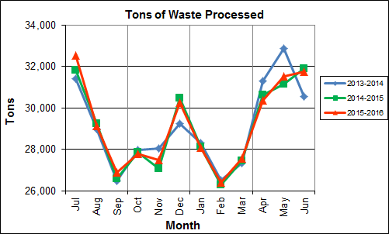

Chart 1 illustrates that Q4FY16 waste processed was slightly lower (less than 0.1%) than the corresponding quarter, Q4FY15.

CAAI reported that 475 tipping floor/MSW internal inspections were conducted during the quarter and two (2) notices of violation (NOVs) were issued to haulers in April 2016 for opening the tailgate on the tipping floor entrance ramp, and delivering a load of refrigerators.

Chart 2: Tons of Ash Produced per Ton of Waste Processed

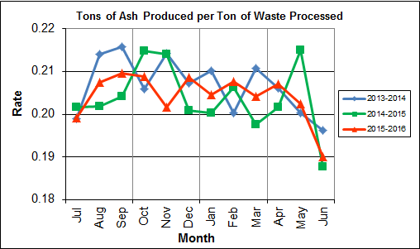

Chart 2 illustrates that the average ash production rate in Q4FY16 was lower (0.8%) at 20.0% of processed waste, compared to the corresponding quarter in FY15 when the rate was 20.1%. Ash production remains in the 20.0% to 21.0% range, as a result of the installation of the “semi-dry” ash discharger spray system in May 2012, and represents less moisture in the ash residue shipped to disposal.

The annual ash production rate for FY16 was identical to FY15 at 20.4%. This result compares very favorably with industry averages which are generally in the range of 25-28%.

Chart 3: Ferrous Recovery Rate

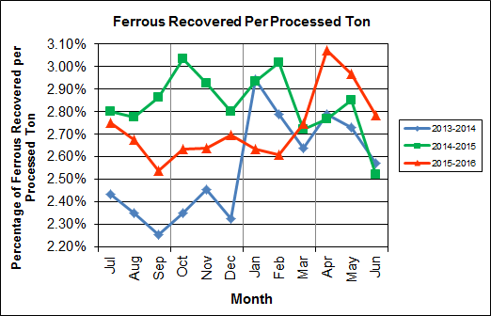

Chart 3 depicts the monthly ferrous metal recovery rate as a percentage of processed MSW tonnage. In Q4FY16, 2,753 tons of ferrous metals were recovered, which is 8.3% higher than the corresponding quarter in FY15 and equivalent to 2.9% of processed waste. CAAI reports that in recent months it was noted that the ferrous recovery rate had decreased and they replaced an end section of the vibrating pan which was worn due to wear from material getting caught between the pan and magnet. The positive impacts of the end section pan replacement is obvious in Chart 3 during Q4FY16 when compared to the previous nine (9) months of FY16 when the ferrous recovery rate was noticeably lower than the recovery rate in FY15.

In FY16, 9,571 tons of ferrous metals were recovered, which is 3.0% lower than FY15 and equivalent to 2.7% of processed waste. As depicted in Chart 3, the first nine (9) months of FY16 had a decreased ferrous recovery rate, compared to the same period in FY15, which was before the end section pan replacement occurred.

Chart 4: Steam Production

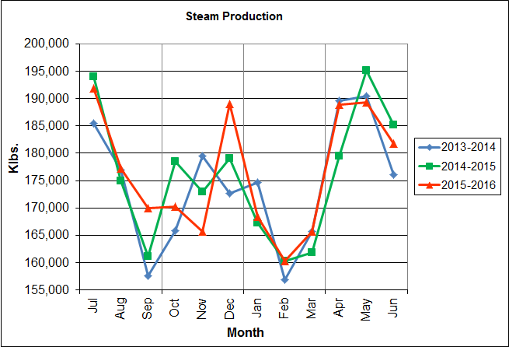

In Chart 4, the total steam production for Q4FY16 was 559,883 klbs., and slightly higher (less than 0.1%) than the corresponding quarter in FY15. The slight increase in steam generation was attributable to the increase (3.6%) in the calculated average waste heating value, offset by more downtime (20 additional hours) experienced by the boilers.

Annual steam production for FY16 was 2,118,125 klbs., or 0.4% higher than FY15 which produced 2,109,442 klbs. The increase in steam generation was attributable to the increase (1.1%) in the calculated average waste heating value, as well as less (111 fewer hours) scheduled, unscheduled, and standby downtime experienced by the boilers and an additional day of operations as a result of the Leap Year.

Chart 5: 12-Month Rolling Steam Production

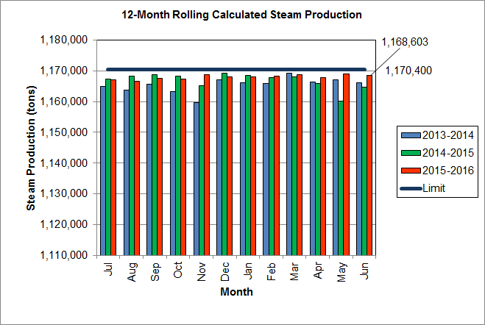

Chart 5 depicts the 12-month rolling steam production total for the period ending in June 2016. According to the Title V permit, the annual steam production for the Facility shall not exceed 1,170,400 tons on the basis of an average value of 3.34 lbs of steam per lb of MSW processed, calculated monthly as the sum of each consecutive 12 month period. The Facility was in compliance with the 12-month rolling steam production total every month in FY16. The 12-month rolling total for steam production ending in June 2016 was 1,168,603 tons which is 99.8% of the limit. Chart 5 clearly shows that Facility throughput, and in turn, steam and electricity production are being throttled to stay ever so slightly below the steam production limit nearly every month.

Chart 6: Steam Production Rate

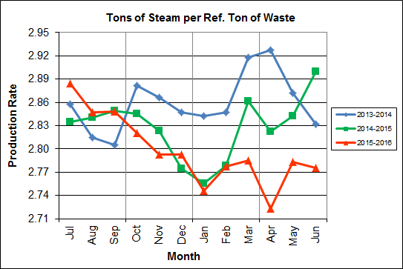

In Chart 6, the conversion of raw waste tonnages into “reference tons” is another way of analyzing steam production, and helps to determine whether changes are related to boiler performance or to fuel issues. “Reference tons” are adjusted to account for the calculated average fuel heating value, so that lower Btu fuel raw tonnages are adjusted upwards and vice versa. In Q4FY16, this metric tracked lower (3.3%) at 2.8 tonssteam/tonref, compared to the corresponding quarter in FY15.

The annual steam production rate for FY16 was 2.8 tonssteam/tonref, which is lower (1.1%) than FY15. This chart shows that for the last four (4) months of FY16, a downtrend was experienced in the normalized steam production rate compared to the same period during the prior two (2) years. This trend should continue to be monitored to determine if it is indicative of poorer boiler performance, an aberration during scheduled outage periods, or some other currently unexplained cause.

Chart 7: Calculated Waste Heating Value

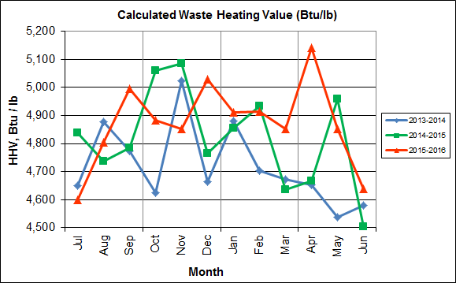

Chart 7 illustrates that Q4FY16 calculated average waste heating value was higher (3.6%) at 4,877 Btu/lb than the corresponding quarter Q4FY15, which averaged 4,710 Btu/lb.

In FY16, the annual average waste heating value was higher (1.1%) at 4,873 Btu/lb than FY15, which averaged 4,819 Btu/lb. Note that the FY16 annual average heating value of 4,873 Btu/lb is 8.3% higher than the facility design value of 4,500 Btu/lb.

Table 2: Quarterly Performance Summaries

|  |  |  |  |  |  |  |  |  |
| --- | --- | --- | --- | --- | --- | --- | --- | --- |
| Month | | Waste Processed (tons) | Waste Diverted  (tons) | Ash Shipped  (tons) | Special Handling (Supplemental)  (tons) | Ferrous Recovered  (tons) | Steam Produced (klbs) | Net Electrical Generation  (MWhr) |
| **Q4FY14** | **Quarterly Totals** | **94,734** | **0** | **19,035** | **514** | **2,556** | **555,969** | **39,409** |
| April-14 | 31,317 | 0 | 6,454 | 253 | 873 | 189,568 | 13,568 |
| May-14 | 32,873 | 0 | 6,585 | 151 | 897 | 190,394 | 13,515 |
| June-14 | 30,544 | 0 | 5,996 | 110 | 786 | 176,007 | 12,326 |
| **Q4FY15** | **Quarterly Totals** | **93,695** | **0** | **18,870** | **1,842** | **2,541** | **559,721** | **36,175** |
| April-15 | 30,646 | 0 | 6,182 | 613 | 848 | 179,434 | 12,784 |
| May-15 | 31,160 | 0 | 6,701 | 531 | 889 | 195,150 | 11,786 |
| June-15 | 31,889 | 0 | 5,987 | 698 | 804 | 185,137 | 11,605 |
| **Q4FY16** | **Quarterly Totals** | **93,652** | **0** | **18,703** | **2,262** | **2,753** | **559,883** | **40,207** |
| April-16 | 30,356 | 0 | 6,289 | 996 | 932 | 188,882 | 13,853 |
| May-16 | 31,530 | 0 | 6,380 | 605 | 936 | 189,239 | 13,541 |
| June-16 | 31,766 | 0 | 6,034 | 661 | 885 | 181,762 | 12,813 |
| **FY16 Totals** | | **349,881** | **0** | **71,401** | **8,567** | **9,571** | **2,118,125** | **148,529** |
| **FY15 Totals** | | **348,686** | **0** | **71,019** | **5,413** | **9,864** | **2,109,442** | **145,085** |
| **FY14 Totals** | | **349,118** | **0** | **72,071** | **3,549** | **8,922** | **2,091,123** | **143,064** |

Table 2 presents the production data provided to HDR by CAAI for Q4FY16 on both a monthly and quarterly basis. For purposes of comparison, data for Q4FY14 and Q4FY15 are also shown, as well as FY14, FY15 and FY16 YTD totals.

In comparing quarterly totals, the data shows:

* Less waste was processed in Q4FY16 than Q4FY15 and Q4FY14
* Less steam was generated in Q4FY16 than Q4FY15 and Q4FY14
* Significantly more electricity was generated in Q4FY16 than Q4FY15 and Q4FY14
* Significantly more supplemental waste was received in Q4FY16 than Q4FY15 and Q4FY14.

Please note that the total steam generation figures presented in Table 2 do not correlate with the annual steam production limit from the Facility Permit; such limits apply on a 12-month rolling average monthly basis, and not a fiscal year basis. It is also worth noting that the quantity of waste processed during Q4FY16 and FY16 continues to be limited by the steam production permit restrictions (refer to Chart 5).

Table 3: Waste Delivery Classification

|  |  |  |  |  |  |  |  |  |  |  |  |  |  |  |  |
| --- | --- | --- | --- | --- | --- | --- | --- | --- | --- | --- | --- | --- | --- | --- | --- |
|  |  | **Jul** | **Aug** | **Sep** | **Oct** | **Nov** | **Dec** | **Jan** | **Feb** | **Mar** | **Apr** | **May** | **Jun** | **Totals** | **% of Total** |
| **FY12** | **Jurisdiction Waste** | 18,112 | 20,021 | 19,304 | 17,796 | 17,523 | 17,211 | 16,202 | 14,952 | 17,430 | 18,338 | 20,138 | 18,361 | 215,381 | 61.89% |
| **Spot Waste tons** | 8,901 | 13,623 | 13,303 | 9,788 | 11,976 | 11,900 | 10,276 | 10,697 | 10,283 | 10,029 | 11,333 | 10,177 | 132,295 | 38.01% |
| **Supplemental Waste** | 10 | 10 | 34 | 15 | 15 | 21 | 12 | 22 | 15 | 23 | 68 | 91 | 336 | 0.10% |
| **MSW Totals** | **27,023** | **33,654** | **32,641** | **27,599** | **29,514** | **29,132** | **26,490** | **25,672** | **27,729** | **28,390** | **31,539** | **28,629** | **348,012** | **100.00%** |
|  |  |  |  |  |  |  |  |  |  |  |  |  |  |  |  |
| **FY13** | **Jurisdiction Waste** | 19,413 | 18,357 | 16,632 | 17,625( | 18,838 | 16,195 | **-** | **-** | **-** | **-** | **-** | **-** | 107,058 | 30.76% |
| **Spot Waste tons** | 10,516 | 11,326 | 10,610 | 10,317 | 9,330 | 9,558 | **-** | **-** | **-** | **-** | **-** | **-** | 61,656 | 17.72% |
| **City Waste** | **-** | **-** | **-** | **-** | **-** | **-** | 1,683(1) | 1,287 | 1,444 | 2,382 | 2,286 | 1,919 | 11,000 | 3.16% |
| **County Waste** | **-** | **-** | **-** | **-** | **-** | **-** | 2,442(1) | 2,100 | 2,372 | 3,381 | 3,932 | 3,309 | 17,536 | 5.04% |
| **Municipal Solid Waste** | **-** | **-** | **-** | **-** | **-** | **-** | 25,019(1) | 23,637 | 21,661 | 27,066 | 25,794 | 24,930 | 148,107 | 42.56% |
| **Supplemental Waste** | 151 | 11 | 80 | 25 | 234 | 405 | 363 | 365 | 76 | 403 | 281 | 271 | 2,665 | 0.77% |
| **MSW Totals** | **29,928** | **29,683** | **27,241** | **27,942** | **28,167** | **25,753** | **29,507** | **27,388** | **25,552** | **33,231** | **32,293** | **30,429** | **348,022** | **100.00%** |
|  |  |  |  |  |  |  |  |  |  |  |  |  |  |  |  |
| **FY14** | **City Waste** | 2,065 | 1,693 | 1,702 | 1,924 | 1,566 | 1,780 | 1,529 | 1,231 | 1,556 | 2,256 | 2,203 | 1,883 | 21,389 | 6.11% |
| **County Waste** | 3,459 | 3,079 | 2,784 | 3,091 | 2,707 | 2,802 | 2,568 | 1,957 | 2,272 | 3,326 | 3,987 | 3,387 | 35,419 | 10.12% |
| **Municipal Solid Waste** | 26,167 | 23,604 | 22,034 | 23,354 | 21,879 | 25,531 | 23,869 | 22,523 | 23,198 | 25,414 | 27,206 | 24,812 | 289,590 | 82.75% |
| **Supplemental Waste** | 546 | 676 | 248 | 410 | 188 | 268 | 275 | 192 | 231 | 253 | 151 | 110 | 3,548 | 1.01% |
| **MSW Totals** | **32,237** | **29,053** | **26,768** | **28,779** | **26,340** | **30,380** | **28,241** | **25,903** | **27,256** | **31,249** | **33,546** | **30,193** | **349,946** | **100.00%** |
|  |  |  |  |  |  |  |  |  |  |  |  |  |  |  |  |
| **FY15** | **City Waste** | 1,814 | 1,497 | 1,699 | 1,737 | 1,518 | 1,770 | 1,411 | 1,209 | 1,648 | 2,155 | 2,059 | 2,045 | 20,562 | 5.91% |
| **County Waste** | 3,297 | 2,868 | 2,973 | 3,095 | 2,508 | 2,852 | 2,358 | 1,833 | 2,411 | 3,269 | 3,652 | 3,572 | 34,687 | 9.96% |
| **Municipal Solid Waste** | 26,661 | 24,466 | 21,887 | 21,241 | 21,678 | 27,906 | 24,611 | 20,915 | 24,094 | 25,189 | 23,126 | 25,667 | 287,442 | 82.57% |
| **Supplemental Waste** | 141 | 275 | 329 | 521 | 764 | 529 | 389 | 351 | 272 | 613 | 531 | 698 | 5,413 | 1.55% |
| **MSW Totals** | **31,913** | **29,106** | **26,888** | **26,595** | **26,468** | **33,057** | **28,769** | **24,308** | **28,424** | **31,225** | **29,369** | **31,982** | **348,105** | **100.00%** |
|  |  |  |  |  |  |  |  |  |  |  |  |  |  |  |  |
| **FY16** | **City Waste** | 1,960 | 1,563 | 1,723 | 1,645 | 1,685 | 1,872 | 1,147 | 1,619 | 1,811 | 2,024 | 1,950 | 2,220 | 21,219 | 6.03% |
| **County Waste** | 3,627 | 2,880 | 2,832 | 2,869 | 2,682 | 2,891 | 2,025 | 2,389 | 2,694 | 2,406 | 2,508 | 2,661 | 32,465 | 9.22% |
| **Municipal Solid Waste** | 27,933 | 22,999 | 22,552 | 22,850 | 20,679 | 26,138 | 22,632 | 22,781 | 22,935 | 24,388 | 26,561 | 27,355 | 289,801 | 82.32% |
| **Supplemental Waste** | 676 | 427 | 771 | 684 | 676 | 787 | 642 | 850 | 792 | 996 | 605 | 661 | 8,565 | 2.43% |
| **MSW Totals** | **34,196** | **27,869** | **27,878** | **28,047** | **25,722** | **31,687** | **26,446** | **27,639** | **28,232** | **29,814** | **31,623** | **32,896** | **352,049** | **100.00%** |
| **Note (1): Beginning January 2013, the method in which waste was classified was modified as compared to prior periods due to change in contractual obligations and plant ownership** | | | | | | | | | | | | | | | |

Chart 8: Cumulative Total Waste Delivery

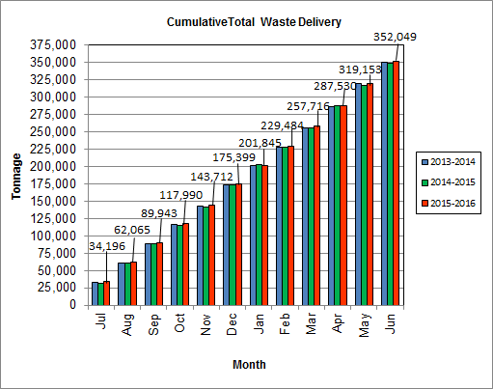

As depicted in Table 3 and Chart 8, for the period ending in June 2016; cumulative total waste delivery was 1.1% more compared to the same period in FY15.

Chart 9: Gross Electrical Generation

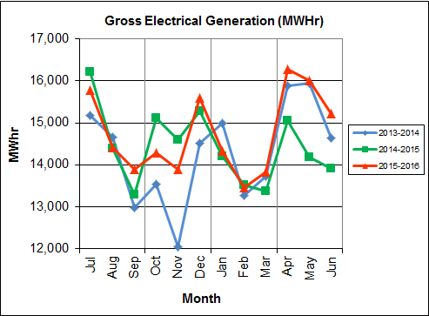

During Q4FY16, the Facility generated 47,521 MWhrs (gross) of electricity compared to Q4FY15 generation of 43,162 MWhrs (gross), a 10.1% increase. The significant increase in gross electrical generation in Q4FY16 as compared to Q4FY15 is attributable to the slight increase in steam production and significantly less downtime (450 fewer hours) experienced by the Turbine Generators. Note that the sharp spikes depicted in Chart Nos. 10 through 14 for the months of May and June 2015 are a result of significant downtime (424.7 hours) experienced by Turbine Generator No. 1 to repair an exciter failure in the generator. A similar spike is depicted in the same charts for November 2013 as a result of Turbine Generator No. 2 experiencing significant downtime (494.8 hours) for a Major Overhaul.

During FY16, the Facility generated 176,967 MWhrs (gross) of electricity compared to the FY15 generation of 173,145, a 2.2% increase. The increase in gross electrical generation in FY16 as compared to FY15 is attributable to the increase in steam production, as well as less (225.7 fewer hours) scheduled, unscheduled, and standby downtime experienced by the turbine generators. Also note that 2016 is a Leap Year and February 2016 had an additional day of operations, when compared to the prior 2 operating years, which positively biases processed tonnage, steam production, and in this instance, electrical generation.

Chart 10: Gross Conversion Rate

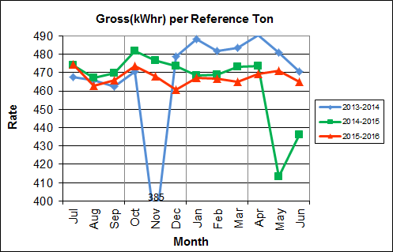

As shown in Chart 10, the average gross electrical generation per reference ton of refuse processed during Q4FY16 was 468 kWhr, which is 6.3% higher than the corresponding quarter in FY15, and is attributable to less downtime experienced by the turbine generators during the quarter when compared to the corresponding quarter in FY15 when repairs were made as a result of the Turbine Generator No. 1 exciter failure. Since this calculated value uses reference or normalized tonnages of waste, it should cancel the effect of MSW heating value (Btu content) variability.

During FY16, the average gross electrical generation per reference ton of refuse processed was 467 kWhr, which is higher (0.6%) than FY15.

Chart 11: Net Conversion Rate

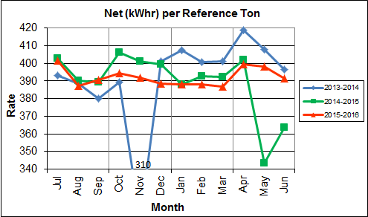

Chart 11 depicts the normalized net power (gross minus in-house usage) generation history. In Q4FY16, the average net electrical generation per reference ton was 396 kWhr, which is 7.2% higher than the corresponding quarter in FY15, and again, attributable to less downtime experienced by the Turbine Generators during the quarter, when compared to the corresponding quarter last fiscal year.

In FY16, the average net electrical generation per reference ton was 392 kWhr, which is 0.8% higher than FY15.

Chart 12: Net Conversion Rate

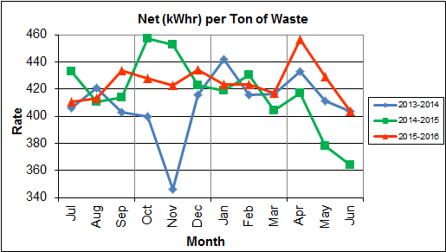

Chart 12 depicts the net power generation per processed ton. The net electrical generation per processed ton in Q4FY16 was 430 kWhr, which is 11.2% higher than the corresponding quarter in FY15, and attributable to less downtime experienced by the turbine generators and higher (3.6%) calculated waste heating value, when compared to the corresponding quarter last fiscal year.

In FY16, the net electrical generation per processed ton was 425 kWhr which is 1.8% higher than FY15.

Chart 13: Gross Turbine Generator Conversion Rate

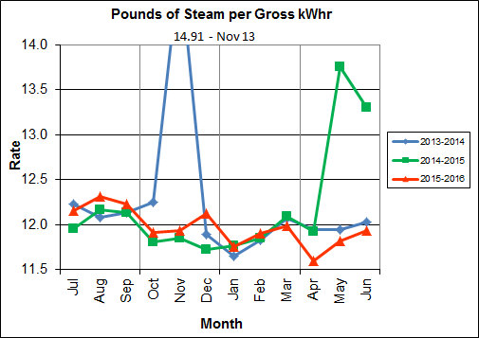

Charts 13 and 14 illustrate the quantities of steam required to generate one (1) kWhr of electricity, gross and net respectively. This measure is a turbine generator performance indicator, where lower steam rates indicate superior performance. For simplification, this calculated rate is based on the average for the two turbine generators. In Q4FY16 the average lbs of steam consumed per gross kWhr generated was 11.8, which is significantly lower (9.2%) than the corresponding quarter Q4FY15, and attributable to less downtime experienced by the turbine generators. Another factor that negatively impacts this metric is Turbine Generator No. 2 continues to operate with its Stage 9 blades removed from the rotor. CAAI reported that during the Turbine Generator No. 2 overhaul in November 2013, some cracking was observed on the Stage 9 blades of the rotor, and the blading in that row was removed as a precautionary measure. CAAI originally indicated that a new set of blades would be manufactured and installed during a Turbine Generator No. 2 Outage in 2016, but advised in May 2015, that the implementation of the replacement blades installation would be delayed, and did not provide a date for repair. The average lbs of steam consumed per net kWhr was 13.9, which is significantly lower (9.2%) than the corresponding quarter in FY15. The average steam temperature during the quarter was 690.4° F, which is 1.4% higher than the average steam temperature of the corresponding quarter last fiscal year and 9.6° F lower than design temperature of 700o F.

In FY16, the average lbs of steam consumed per gross kWhr was 12.0, which is 1.8% lower than the rate in FY15, noting that for this metric, lower steam consumption represents improved performance. The average lbs of steam consumed per net kWhr in FY16 was 14.3, which is 1.9% lower than the rate in FY15. The average steam temperature for FY16 was 680.5o F, which is slightly higher (less than 0.1%) than the steam temperature in FY15 and 19.5o F lower than the design temperature of 700o F.

Chart 14: Net Turbine Generator Conversion Rate

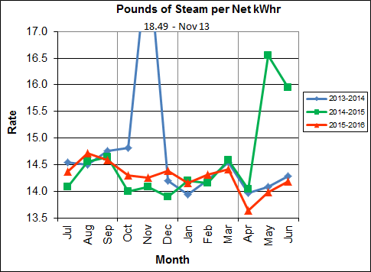

## Utility and Reagent Consumptions

Table 4: Facility Utility and Reagent Consumptions

|  |  |  |  |  |  |  |  |
| --- | --- | --- | --- | --- | --- | --- | --- |
| **Utility** | **Units** | **Q4FY16 Total** | **Q4FY15**  **Total** | **Q4FY16”Per Processed Ton” Consumption** | **Q4FY15”Per Processed Ton” Consumption** | **FY16**  **Total** | **FY15**  **Total** |
| **Purchased Power** | MWhr | 5,651 | 5,477 | 0.06 | 0.06 | 22,242 | 22,001 |
| **Fuel Oil** | Gal. | 11,590 | 5,640 | 0.12 | 0.06 | 41,110 | 35,920 |
| **Boiler Make-up** | Gal. | 1,794,000 | 2,090,000 | 19.16 | 22.31 | 7,813,000 | 8,501,000 |
| **Cooling Tower Make-up** | Gal. | 42,074,659 | 44,595,720 | 449.27 | 475.97 | 146,912,669 | 143,594,395 |
| **Pebble Lime** | Lbs. | 1,344,000 | 1,386,000 | 14.35 | 14.79 | 5,378,000 | 5,254,000 |
| **Ammonia** | Lbs. | 183,000 | 159,000 | 1.95 | 1.70 | 663,000 | 632,000 |
| **Carbon** | Lbs. | 98,000 | 102,000 | 1.05 | 1.09 | 404,000 | 408,000 |
| **Dolomitic Lime** | Lbs. | 138,000 | 294,000 | 1.47 | 3.14 | 701,800 | 995,200 |

Fuel oil usage during the quarter represents approximately 0.19% of the total heat input to the boilers, which compares favorably with industry averages, and slightly higher than the percentage of heat input in Q4FY15 which was 0.09%. Fuel oil is used to stabilize combustion of wet fuel, as well as during start-up and shut-down of the boilers for maintenance. Boiler makeup water usage during the quarter represents 2.7% of steam flow, which is lower than the boiler makeup in Q4FY15 which was 3.1%, and is acceptable. Pebble lime usage, at 1,344,000 lbs. is lower (3.0%) than the corresponding quarter last year, and the quarterly consumption rate of 14.4 lbs/ton is below historical levels (16-18 lbs/ton).

In comparing Q4FY16 to Q4FY15 on a per processed ton consumption basis:

* the purchased power consumption rate was 3.2% higher
* the total fuel oil consumption rate was 105.6% higher
* the boiler make-up water consumption rate was 14.1% higher
* the cooling tower make-up water consumption rate was 5.6% lower
* the total pebble lime consumption rate was 3.0% lower
* the ammonia consumption rate was 15.2% higher
* the carbon consumption rate was 3.9% lower
* the total dolomitic lime consumption rate was 53.0% lower

Note that following the February 2016 FMG Meeting, CAAI provided 3 year historical dolomitic lime usage based on deliveries, starting silo inventory, and ending silo inventory. CAAI reports that the significant decrease in dolomitic lime usage during the quarter, when compared to the corresponding quarter last year, is attributable to a dolomitic lime silo level detector malfunction from June 25, 2015 through July 9, 2015.  As a result of this malfunction, CAAI stated that delivery totals were utilized as usage totals during those months last fiscal year.  CAAI also reported that they have been decreasing usage in recent months based on pH levels (average in-house pH of 9.4 during Q4FY16).

## Safety & Environmental Training

The Facility had no recordable accidents during the quarter and has operated 166 days without an OSHA recordable incident through the end of September 2015. During the quarter, Safety and Environmental training was conducted with themes as follows:

**April 2016**

* Safety:
  + Hearing Conservation
  + Bloodborne Pathogens
  + Hand and Finger Injuries and Prevention
  + Grinder Safety
* Environmental:
  + Spill Prevention Control
  + Countermeasure Plan

**May 2016**

* Safety:
  + Confined Spaces
  + Fall Protection and Prevention
  + Teamwork and Communication
* Environmental:
  + The Three R’s (Recognizing, Reporting, and Responding)
  + Environmental Awareness

**June 2016**

* Safety:
  + Emergency Action Plan
  + Fire Extinguisher Usage
  + Flammable/Combustible Storage
  + First Aid and Medical Emergencies
* Environmental:
  + Metals Recovery
  + Ash Re-use

# Facility Maintenance

Throughout the quarter, significant routine and preventative maintenance was performed. HDR considers that the Facility is implementing an effective maintenance regimen, and is performing routine and preventative maintenance, along with selected equipment replacements in a timely manner. CAAI monthly maintenance reports provide a detailed account of maintenance performed.

Beginning June 27, 2016 Boiler No. 2 experienced 25.3 hours of downtime for a scheduled cleaning outage. Some significant maintenance activities that occurred during the outage were:

* Change-out of three (3) broken grate bars
* Replacement of coupling, bearing housings, bearings, seals, on Over Fire Air Fan
* Change-out of motor and flexible conduit on Over Fire Air Fan

In addition to the scheduled maintenance, CAAI reports that 811 preventative maintenance actions were completed during the quarter.

## Availability

Facility availabilities for Q4FY16 are shown in Table 5. According to CAAI reports, the average unit availabilities for Boiler Nos. 1, 2, and 3 for Q4FY16 were 99.5%, 98.8%, and 99.1%, respectively. The three-boiler average availability during the quarter was 99.2%, which is excellent.

During Q4FY16, the average availability for Turbine Generator Nos. 1 and 2 was 100.0% and 99.7%, respectively. The two-turbine generator average availability during the quarter was 99.9%, which is excellent.

Overall boiler availability for FY16 was 96.5%, and overall turbine generator availability was 98.9%. Overall availabilities for the boilers are highly acceptable and above industry averages, noting that these reported availability metrics exclude standby time experienced during the fiscal year which amounted to 322.1 hours for the boilers and 347.1 hours for the turbine generators.

Table 5: Quarterly Facility Unit Availabilities

|  |  |  |  |  |  |
| --- | --- | --- | --- | --- | --- |
| **Availability** | **Q1FY16 Average** | **Q2FY16 Average** | **Q3FY16 Average** | **Q4FY16**  **Average** | **FY16 Average** |
| Boiler No. 1 | 94.1% | 100.0% | 92.8% | 99.5% | 96.6% |
| Boiler No. 2 | 97.9% | 94.6% | 93.9% | 98.8% | 96.3% |
| Boiler No. 3 | 98.5% | 94.4% | 93.8% | 99.1% | 96.5% |
| ***Avg.*** | ***96.8%*** | ***96.3%*** | ***93.5%*** | ***99.2%*** | ***96.5%*** |
| Turbine No. 1 | 99.0% | 100.0% | 93.8% | 100.0% | 98.2% |
| Turbine No. 2 | 99.1% | 100.0% | 99.5% | 99.7% | 99.6% |
| ***Avg.*** | ***99.0%*** | ***100.0%*** | ***96.6%*** | ***99.9%*** | ***98.9%*** |

## Downtime Summary

Table 6: Boiler Downtime – Q4FY16

|  |  |  |  |  |  |  |
| --- | --- | --- | --- | --- | --- | --- |
| **Boiler Number** | **Outage Begin Date** | **Outage End Date** | **Hours Unavailable** | | **Downtime**  **Classification** | **Reason Unavailable** |
| 1 | 5/5/16 | 5/5/16 | 10.7 | | Unscheduled | Grate bar failure |
| 3 | 6/25/16 | 6/25/16 | 19.5 | | Unscheduled | Tube leak repairs |
| 2 | 6/27/16 | 6/28/16 | 25.3 | | Scheduled | Boiler No. 2 scheduled cleaning outage |
| **Total Unscheduled Downtime** | | | | **30.2 Hours** | | |
| **Total Scheduled Downtime** | | | | **25.3 Hours** | | |
| **Total Standby Downtime** | | | | **0.0 Hours** | | |
| **Total Downtime** | | | | **55.5 Hours** | | |

Table 7: Turbine Generator Downtime – Q4FY16

|  |  |  |  |  |  |  |
| --- | --- | --- | --- | --- | --- | --- |
| **Turbine Generator Number** | **Outage Begin Date** | **Outage End Date** | **Hours Unavailable** | | **Downtime**  **Classification** | **Reason Unavailable** |
| 2 | 5/19/16 | 5/19/16 | 6.7 | | Unscheduled | Condenser tube leak repairs |
| **Total Unscheduled Downtime** | | | | **6.7 Hours** | | |
| **Total Scheduled Downtime** | | | | **0.0 Hours** | | |
| **Total Standby Downtime** | | | | **0.0 Hours** | | |
| **Total Downtime** | | | | **6.7 Hours** | | |

## Facility Housekeeping

CAAI is performing Facility housekeeping and maintaining plant cleanliness in accordance with acceptable industry practices. A site inspection was conducted in May 2016. At the time of the inspection, new deficiencies were recorded and prior deficiencies were given a status update. Photos of interest from the inspection are depicted in Appendix B. The Facility housekeeping ratings from the February 2016 inspection are presented in Table 8.

Table 8: Facility Housekeeping Ratings – May 2016

| **Facility Area** | **Acceptable** | **Needs Improvement** | **Unacceptable** |
| --- | --- | --- | --- |
| **Tipping Floor** | √ |  |  |
| **Citizen’s Drop-off Area** | √ |  |  |
| **Tipping Floor Truck Exit** | √ |  |  |
| **Front Parking Lot** | √ |  |  |
| **Rear Parking Lot** | √ |  |  |
| **Boiler House Pump Room** | √ |  |  |
| **Lime Slurry Pump Room** | √ |  |  |
| **Switchgear Area** | √ |  |  |
| **Ash Load-out Area** | √ |  |  |
| **Vibrating Conveyor Area** | √ |  |  |
| **Ash Discharger Area** | √ |  |  |
| **Cooling Tower Area** | √ |  |  |
| **Truck Scale Area** | √ |  |  |
| **SDA/FF Conveyor Area** | √ |  |  |
| **SDA Penthouses** | √ |  |  |
| **Lime Preparation Area** | √ |  |  |
| **Boiler Drum Levels** | √ |  |  |
| **Turbine Room** | √ |  |  |
| **Electrical Room** | √ |  |  |

# Environmental

The air pollution control equipment maintained emission concentrations well within the established regulations. Average Continuous Emission Monitoring System (CEMS) data collected for each monthly period during Q4FY16 are summarized in Appendix A. No permit deviations were reported by the Facility during Q4FY16.

On August 8, 2014, CAAI sent a letter to the Virginia Department of Environmental Quality (VADEQ) requesting relief from the steam permit limit requirements in the Facility’s Title V and PSD permits. These requested changes relate to the permit values established for the calculated steam-to-waste ratio, which has resulted in a reduction of MSW throughput. In recent discussions, CAAI indicated that it is re-evaluating options to the proposed permit changes, and will provide further updates on this issue.

## Nitrogen Oxide Emissions

During Q4FY16, the monthly emission concentrations of nitrogen oxides (NOx) averaged 161.0 ppmdv, 160.7 ppmdv and 161.0 ppmdv for Boiler Nos. 1, 2, and 3, respectively. CAAI continues to operate the units at the lower (160 ppmdv) set-points, except immediately following a scheduled outage and associated boiler cleaning.

## Sulfur Dioxide Emissions

During Q4FY16 the monthly emission concentration of stack sulfur dioxide (SO2) averaged 1.7 ppmdv, 0.7 ppmdv, and 1.3 ppmdv for Boiler Nos. 1, 2, and 3, respectively. All of these stack SO2 concentrations are significantly below the 40 CFR Subpart Cb requirement of 29 ppmdv @ 7% O2.

## Carbon Monoxide Emissions

During Q4FY16, the average CO emission concentrations on Boiler Nos. 1, 2, and 3 were 39.7 ppmdv, 38.3 ppmdv, and 37.3 ppmdv, respectively, and all are well within permit limits (100 ppmdv, hourly average). However, as reported by HDR during the May 2016 FMG Meeting, CO averages have been trending higher over the past six (6) months on all three boilers, and CAAI has been requested to investigate and mitigate this uptrend. While not a permit issue, it is indicative of poorer boiler performance and combustion efficiency.

## Opacity

During Q4FY16, the average opacity for Boiler Nos. 1, 2, and 3 was 1.4%, 0.1%, and 0.8% respectively. All of these averages are significantly below the 10% (6-minute) average permit limit.

## Daily Emissions Data

Appendix A, Tables 10, 11, and 12 tabulate the monthly average, maximum, and minimum emissions data for each unit during Q4FY16. Excursions, if any, would appear in bold print. It should be noted that these tabulations of monthly averages, reported here for informational purposes, are based on tabulations of daily averages. These averages do not correlate with official reports to the regulatory agencies because of differences in averaging times and other technical differences required by agency report formats.

## 2016 Annual Stack Testing

Annual stack testing was conducted March 21st through March 23rd, 2016 by Testar Inc. Historical stack test data including 2016 results are summarized in Chart 15 and Table 9. The 2016 test results demonstrate compliance well within the permit limits for all parameters. In addition to the tests required by the Facility permit, additional tests for small particulate matter (PM < 2.5) were conducted. While there are no current regulatory limits established for PM < 2.5, average results for 2016 were 0.005 Gr/DSCF (grains per dry standard cubic foot) corrected to 7% O­2, compared to the 2015 Annual Stack Testing PM <2.5 Results which averaged 0.003 Gr/DSCF corrected to 7% O­2.

Chart 15: Stack Test Results through 2016

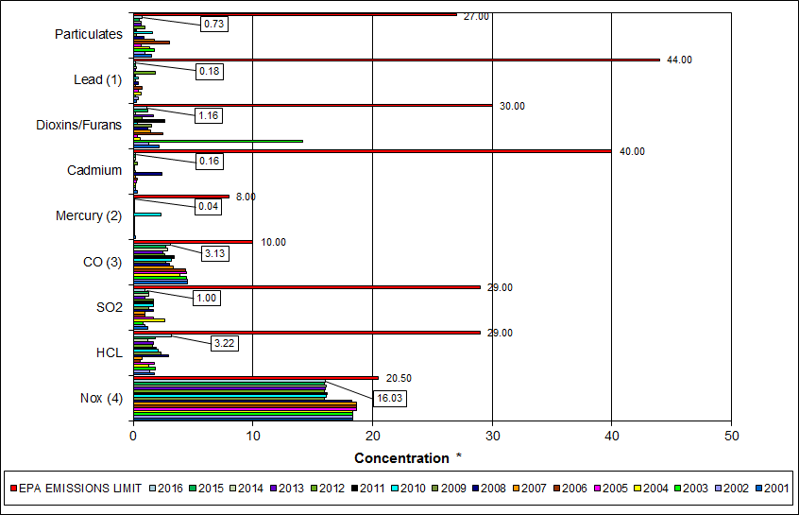

|  |
| --- |
| Note (1): Lead emissions have been decreased by a factor of 10 for trending purposes |
| Note (2): Mercury emissions have been decreased by a factor of 100 for trending purposes |
| Note (3): CO emissions have been decreased by a factor of 10 for trending purposes |
| Note (4): NOx emissions have been decreased by a factor of 10 for trending purposes |

Table 9: Stack Test Results through 2016

|  |  |  |  |  |  |  |  |  |  |  |  |
| --- | --- | --- | --- | --- | --- | --- | --- | --- | --- | --- | --- |
|  |  | **NOx(4)** | **HCL** | **SO2** | **CO(3)** | **Mercury(2)** | **Cadmium** | **Dioxins/Furans** | **Lead(1)** | **Particulates** | **P.M. 2.5** |
|  |  | **(ppmdv)** | **(ppmdv)** | **(ppmdv)** | **(ppmdv)** | **(ug/dscm)** | **(ug/dscm)** | **(ng/dscm)** | **(ug/dscm)** | **(mg/dscm)** | **(gr/dscf)** |
| **2006** | Boiler 1 | 187 | 0.85 | 1 | 43 | 0.38 | 0.4 |  | 7.79 | 4.84 | -- |
| Boiler 2 | 185 | 0.483 | 1 | 47 | 0.4 | 0.19 |  | 2.51 | 2.15 | -- |
| Boiler 3 | 189 | 0.529 | 1 | 42 | 0.4 | 0.57 | 2.48 | 12.4 | 2 | -- |
| **AVERAGE** | **187.0** | **0.62** | **1.00** | **44.00** | **0.39** | **0.39** | **2.48** | **7.57** | **3.00** | **--** |
|  |  |  |  |  |  |  |  |  |  |  |  |
| **2007** | Boiler 1 | 187 | 0.82 | 1 | 31 | 0.38 | 0.25 |  | 2.31 | 2.03 | -- |
| Boiler 2 | 185 | 0.68 | 1 | 36 | 0.39 | 0.19 | 1.42 | 2.12 | 2.04 | -- |
| Boiler 3 | 189 | 0.84 | 1 | 34 | 0.59 | 0.16 |  | 1.55 | 1.33 | -- |
| **AVERAGE** | **187.0** | **0.78** | **1.00** | **33.67** | **0.46** | **0.20** | **1.42** | **1.99** | **1.80** | **--** |
|  |  |  |  |  |  |  |  |  |  |  |  |
| **2008** | Boiler 1 | 181 | 2.96 | 2 | 37 | 0.45 | 6.60 | 1.25 | 9.4 | 1.46 | -- |
| Boiler 2 | 182 | 3.52 | 2 | 30 | 0.42 | 0.50 |  | 2.6 | 0.82 | -- |
| Boiler 3 | 186 | 2.43 | 1 | 24 | 1.03 | 0.16 |  | 0.23 | 0.48 | -- |
| **AVERAGE** | **183.0** | **3.0** | **1.67** | **30.3** | **0.63** | **2.4** | **1.25** | **4.1** | **0.9** | **--** |
|  |  |  |  |  |  |  |  |  |  |  |  |
| **2009** | Boiler 1 | 159 | 1.40 | 2 | 28 | 0.184 | 0.191 |  | 2.260 | 0.483 | -- |
| Boiler 2 | 158 | 2.12 | 1 | 25 | 0.271 | 0.143 |  | 0.894 | 0.068 | -- |
| Boiler 3 | 163 | 3.53 | 1 | 29 | 0.198 | 0.256 | 1.54 | 3.030 | 0.155 | -- |
| **AVERAGE** | **160** | **2.35** | **1.33** | **27.33** | **0.22** | **0.20** | **1.54** | **2.061** | **0.235** | **--** |
|  |  |  |  |  |  |  |  |  |  |  |  |
| **2010** | Boiler 1 | 159 | 2.69 | 1 | 29 | 5.76 | 0.120 |  | 1.33 | 3.690 | 0.00410 |
| Boiler 2 | 158 | 0.67 | 1 | 28 | 29.50 | 0.032 | 0.35 | 3.00 | 0.914 | 0.00630 |
| Boiler 3 | 168 | 2.85 | 3 | 38 | 34.70 | 0.241 |  | 8.71 | 0.336 | 0.00990 |
| **AVERAGE** | **161.7** | **2.07** | **1.67** | **31.67** | **23.32** | **0.13** | **0.35** | **4.347** | **1.647** | **0.007** |
|  |  |  |  |  |  |  |  |  |  |  |  |
| **2011** | Boiler 1 | 167 | 2.15 | 2 | 28 | 0.36 | 0.140 | 2.67 | 1.72 | 0.130 | 0.00570 |
| Boiler 2 | 159 | 1.14 | 1 | 38 | 0.44 | 0.140 |  | 1.46 | 0.350 | 0.00690 |
| Boiler 3 | 161 | 2.40 | 2 | 37 | 0.36 | 0.110 |  | 1.47 | 0.350 | 0.00170 |
| **AVERAGE** | **162.3** | **1.90** | **1.67** | **34.33** | **0.39** | **0.13** | **2.67** | **1.550** | **0.277** | **0.005** |
|  |  |  |  |  |  |  |  |  |  |  |  |
| **2012** | Boiler 1 | 163 | 1.14 | 2 | 23 | 0.30 | 0.310 |  | 1.34 | 0.640 | 0.00932 |
| Boiler 2 | 156 | 2.02 | 2 | 29 | 0.34 | 0.250 | **0.75** | 6.52 | 1.280 | 0.00782 |
| Boiler 3 | 161 | 1.66 | 1 | 27 | 0.37 | 0.590 |  | 47.80 | 1.020 | 0.00679 |
| **AVERAGE** | **160.0** | **1.61** | **1.67** | **26.33** | **0.34** | **0.38** | **0.75** | **18.553** | **0.980** | **0.008** |
|  |  |  |  |  |  |  |  |  |  |  |  |
| **2013** | Boiler 1 | 164 | 1.48 | 1 | 28 | 0.36 | 0.134 |  | 1.45 | 0.637 | 0.00637 |
| Boiler 2 | 158 | 1.98 | 1 | 25 | 0.37 | 0.112 | 1.66 | 1.05 | 0.737 | 0.00475 |
| Boiler 3 | 159 | 1.52 | 1 | 22 | 0.42 | 0.137 |  | 3.03 | 0.733 | 0.00471 |
| **AVERAGE** | **160.3** | **1.66** | **1.00** | **25.00** | **0.38** | **0.13** | **1.66** | **1.843** | **0.702** | **0.005** |
|  |  |  |  |  |  |  |  |  |  |  |  |
| **2014** | Boiler 1 | 167 | 1.13 | 2 | 35 | 0.33 | 0.270 | 0.16 | 3.82 | 0.282 | 0.00337 |
| Boiler 2 | 157 | 1.02 | 1 | 35 | 0.35 | 0.183 |  | 2.52 | 1.240 | 0.00415 |
| Boiler 3 | 161 | 1.50 | 1 | 17 | 0.49 | 0.228 |  | 2.85 | 0.520 | 0.00425 |
| **AVERAGE** | **161.7** | **1.22** | **1.33** | **29.00** | **0.39** | **0.23** | **0.16** | **3.063** | **0.681** | **0.004** |
|  |  |  |  |  |  |  |  |  |  |  |  |
| **2015** | Boiler 1 | 164 | 1.80 | 2 | 25 | 0.32 | 0.102 |  | 1.00 | 0.513 | 0.00540 |
| Boiler 2 | 157 | 1.99 | 1 | 29 | 0.38 | 0.109 |  | 1.30 | 0.532 | 0.00410 |
| Boiler 3 | 159 | 1.71 | 1 | 27 | 0.39 | 0.409 | 1.21 | 3.04 | 0.499 | 0.00074 |
| **AVERAGE** | **160.0** | **1.83** | **1.33** | **27.00** | **0.36** | **0.21** | **1.21** | **1.778** | **0.515** | **0.003** |
|  |  |  |  |  |  |  |  |  |  |  |  |
| **2016** | Boiler 1 | 166 | 4.33 | 1.0 | 29 | 0.46 | 0.231 |  | 2.81 | 1.170 | 0.00680 |
| Boiler 2 | 156 | 3.46 | 1.0 | 37 | 0.43 | 0.154 | 1.16 | 1.13 | 0.657 | 0.00241 |
| Boiler 3 | 159 | 1.86 | 1.0 | 28 | 0.38 | 0.107 |  | 1.59 | 0.371 | 0.00456 |
| **AVERAGE** | **160.3** | **3.22** | **1.00** | **31.33** | **0.42** | **0.16** | **1.16** | **1.843** | **0.733** | **0.005** |
|  |  |  |  |  |  |  |  |  |  |  |  |
|  | **EPA EMISSIONS LIMIT** | 205 | 29 | 29 | 100 | 80 | 40 | 30 | 440 | 27 | -- |
| **Percent of Limit for 2016** | **78.2%** | **11.1%** | **3.4%** | **31.3%** | **0.5%** | **0.4%** | **3.9%** | **0.4%** | **2.7%** | -- |

## 

## Ash System Compliance

The dolomitic lime feed rate is adjusted periodically in order to maintain a desired ash pH level in the range of 8.0 to 11.0. Since initial startup, the feed rate has varied from between 1 to 9 lbs per ton each month. Ash Toxicity (TCLP) tests were not performed during Q4FY16.

CAAI also samples ash monthly in-house, and documents pH reading to adjust dolomitic lime feed rate. The results for the ash pH tests are found below in Chart 16 where each quarter is represented by the average of the respective monthly readings. During Q4FY16, the average ash pH for in-house tests was 9.4.

Chart 16: Quarterly Ash Test Results

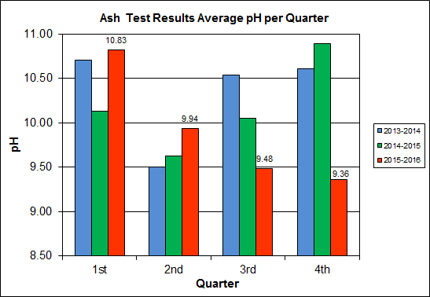

APPENDIX A  
FACILITY CEMS DATA

Table 10: Unit #1 Monthly Summary for Reportable Emissions Data

|  |  |  |  |  |  |  |  |  |  |  |
| --- | --- | --- | --- | --- | --- | --- | --- | --- | --- | --- |
| **Group#-Channel#** | | **G8-C35** | **G8-C28** | **G8-C8** | **G8-C4** | **G8-C12** | **G8-C34** | **G8-C37** | **G8-C40** | **G8-C39** |
| **Long Descrip.** | | **U-1 Steam** | **U-1 Econ** | **U-1 Stack** | **U-1 Stack** | **U-1 Stack** | **U-1 Opaci** | **U-1 FF In** | **U-1 Carbo** | **U-1 Lime** |
| **Short Descrip.** | | **SteamFl** | **SO2ec** | **SO2sc** | **COsc** | **NOxsc** | **Opacity** | **FF InTemp** | **CarbInj** | **LimeFlow** |
| **Units** | | **K#/Hr** | **ppmc** | **ppm** | **ppmc** | **ppmc** | **%** | **deg F** | **#/hr** | **gpm** |
| **Range** | | **0-100** | **0-2000** | **0-500** | **0-4000** | **0-1000** | **0-100** | **100-500** | **0-50** | **0-20** |
| Apr-16 | AVG | 84.7 | 42.0 | 1.0 | 45.0 | 163.0 | 1.5 | 299.0 | 16.3 | 3.1 |
| Max | 86.9 | 62.0 | 5.0 | 62.0 | 193.0 | 2.0 | 306.0 | 16.7 | 3.4 |
| Min | 79.6 | 26.0 | 0.0 | 32.0 | 158.0 | 1.0 | 298.0 | 16.2 | 2.7 |
| May-16 | AVG | 84.3 | 34.0 | 2.0 | 37.0 | 160.0 | 1.3 | 299.0 | 15.6 | 3.0 |
| Max | 90.9 | 62.0 | 4.0 | 50.0 | 165.0 | 1.8 | 299.0 | 17.0 | 3.2 |
| Min | 76.2 | 18.0 | 0.0 | 29.0 | 154.0 | 1.0 | 296.0 | 15.1 | 2.8 |
| Jun-16 | AVG | 84.7 | 24.0 | 2.0 | 37.0 | 160.0 | 1.4 | 299.0 | 15.5 | 3.0 |
| Max | 86.5 | 44.0 | 5.0 | 45.0 | 162.0 | 2.0 | 301.0 | 16.0 | 3.4 |
| Min | 82.5 | 8.0 | 0.0 | 26.0 | 158.0 | 1.1 | 299.0 | 15.3 | 2.7 |
| **Quarter Average** | | 84.6 | 33.3 | 1.7 | 39.7 | 161.0 | 1.4 | 299.0 | 15.8 | 3.0 |
| **Quarter Max Value** | | 90.9 | 62.0 | 5.0 | 62.0 | 193.0 | 2.0 | 306.0 | 17.0 | 3.4 |
| **Quarter Min Value** | | 76.2 | 8.0 | 0.0 | 26.0 | 154.0 | 1.0 | 296.0 | 15.1 | 2.7 |
| **Limits:** | | 98 | NA | 29 | 100 | 205 | 10 | 333 | 16(a) |  |

(a) Carbon flow limit is a minimum value

* Note: The data reported herein represent 24 hour average data for all parameters. Emissions excursions that are measured on shorter time intervals (i.e., 4-hour block averages for CO) do not correlate with the 24 hour average data reported above.

Table 11: Unit #2 Monthly Summary for Reportable Emissions Data

|  |  |  |  |  |  |  |  |  |  |  |
| --- | --- | --- | --- | --- | --- | --- | --- | --- | --- | --- |
| **Group#-Channel#** | | **G8-C35** | **G8-C28** | **G8-C8** | **G8-C4** | **G8-C12** | **G8-C34** | **G8-C37** | **G8-C40** | **G8-C39** |
| **Long Descrip.** | | **U-2 Steam** | **U-2 Econ** | **U-2 Stack** | **U-2 Stack** | **U-2 Stack** | **U-2 Opaci** | **U-2 FF In** | **U-2 Carbo** | **U-2 Lime** |
| **Short Descrip.** | | **SteamFl** | **SO2ec** | **SO2sc** | **COsc** | **NOxsc** | **Opacity** | **FF InTemp** | **CarbInj** | **LimeFlow** |
| **Units** | | **K#/Hr** | **ppmc** | **ppm** | **ppmc** | **ppmc** | **%** | **deg F** | **#/hr** | **gpm** |
| **Range** | | **0-100** | **0-2000** | **0-500** | **0-4000** | **0-1000** | **0-100** | **100-500** | **0-50** | **0-20** |
| Apr-16 | AVG | 87.5 | 42.0 | 1.0 | 39.0 | 161.0 | 0.1 | 299.0 | 16.3 | 3.2 |
| Max | 88.3 | 66.0 | 4.0 | 51.0 | 189.0 | 0.2 | 300.0 | 16.6 | 3.9 |
| Min | 86.1 | 26.0 | 0.0 | 28.0 | 157.0 | 0.0 | 296.0 | 16.1 | 2.8 |
| May-16 | AVG | 84.6 | 30.0 | 0.0 | 40.0 | 160.0 | 0.0 | 299.0 | 15.6 | 3.1 |
| Max | 89.5 | 56.0 | 2.0 | 53.0 | 161.0 | 0.2 | 300.0 | 16.4 | 3.4 |
| Min | 76.4 | 15.0 | 0.0 | 28.0 | 159.0 | 0.0 | 294.0 | 15.1 | 2.9 |
| Jun-16 | AVG | 86.0 | 37.0 | 1.0 | 36.0 | 161.0 | 0.1 | 300.0 | 15.4 | 3.1 |
| Max | 88.6 | 99.0 | 6.0 | 50.0 | 165.0 | 0.3 | 303.0 | 17.4 | 3.8 |
| Min | 83.8 | 17.0 | 0.0 | 25.0 | 159.0 | 0.0 | 299.0 | 15.2 | 2.9 |
| **Quarter Average** | | 86.0 | 36.3 | 0.7 | 38.3 | 160.7 | 0.1 | 299.3 | 15.8 | 3.1 |
| **Quarter Max Value** | | 89.5 | 99.0 | 6.0 | 53.0 | 189.0 | 0.3 | 303.0 | 17.4 | 3.9 |
| **Quarter Min Value** | | 76.4 | 15.0 | 0.0 | 25.0 | 157.0 | 0.0 | 294.0 | 15.1 | 2.8 |
| **Limits:** | | 96 | NA | 29 | 100 | 205 | 10 | 330 | 16(a) |  |

(a) Carbon flow limit is a minimum value

* Note: The data reported herein represent 24 hour average data for all parameters. Emissions excursions that are measured on shorter time intervals (i.e., 4-hour block averages for CO) do not correlate with the 24 hour average data reported above.

Table 12: Unit #3 Monthly Summary for Reportable Emissions Data

|  |  |  |  |  |  |  |  |  |  |  |
| --- | --- | --- | --- | --- | --- | --- | --- | --- | --- | --- |
| **Group#-Channel#** | | **G8-C35** | **G8-C28** | **G8-C8** | **G8-C4** | **G8-C12** | **G8-C34** | **G8-C37** | **G8-C40** | **G8-C39** |
| **Long Descrip.** | | **U-3 Steam** | **U-3 Econ** | **U-3 Stack** | **U-3 Stack** | **U-3 Stack** | **U-3 Opaci** | **U-3 FF In** | **U-3 Carbo** | **U-3 Lime** |
| **Short Descrip.** | | **SteamFl** | **SO2ec** | **SO2sc** | **COsc** | **NOxsc** | **Opacity** | **FF InTemp** | **CarbInj** | **LimeFlow** |
| **Units** | | **K#/Hr** | **ppmc** | **ppm** | **ppmc** | **ppmc** | **%** | **deg F** | **#/hr** | **gpm** |
| **Range** | | **0-100** | **0-2000** | **0-500** | **0-4000** | **0-1000** | **0-100** | **100-500** | **0-50** | **0-20** |
| Apr-16 | AVG | 89.6 | 57.0 | 2.0 | 36.0 | 163.0 | 1.0 | 302.0 | 16.3 | 3.3 |
| Max | 90.8 | 85.0 | 6.0 | 50.0 | 191.0 | 1.4 | 304.0 | 16.9 | 3.8 |
| Min | 87.8 | 39.0 | 0.0 | 25.0 | 159.0 | 0.6 | 299.0 | 16.1 | 2.9 |
| May-16 | AVG | 85.8 | 38.0 | 1.0 | 38.0 | 160.0 | 0.9 | 297.0 | 15.7 | 3.2 |
| Max | 91.3 | 64.0 | 6.0 | 54.0 | 166.0 | 1.3 | 299.0 | 16.9 | 3.4 |
| Min | 76.4 | 20.0 | 0.0 | 25.0 | 158.0 | 0.6 | 293.0 | 15.2 | 2.9 |
| Jun-16 | AVG | 86.7 | 34.0 | 1.0 | 38.0 | 160.0 | 0.4 | 294.0 | 16.1 | 3.0 |
| Max | 89.0 | 51.0 | 4.0 | 51.0 | 166.0 | 0.9 | 295.0 | 17.6 | 3.4 |
| Min | 79.3 | 19.0 | 0.0 | 24.0 | 151.0 | 0.0 | 291.0 | 15.3 | 2.7 |
| **Quarter Average** | | 87.4 | 43.0 | 1.3 | 37.3 | 161.0 | 0.8 | 297.7 | 16.0 | 3.2 |
| **Quarter Max Value** | | 91.3 | 85.0 | 6.0 | 54.0 | 191.0 | 1.4 | 304.0 | 17.6 | 3.8 |
| **Quarter Min Value** | | 76.4 | 19.0 | 0.0 | 24.0 | 151.0 | 0.0 | 291.0 | 15.2 | 2.7 |
| **Limits:** | | 98 | NA | 29 | 100 | 205 | 10 | 327 | 16(a) |  |

(a) Carbon flow limit is a minimum value

* Note: The data reported herein represent 24 hour average data for all parameters. Emissions excursions that are measured on shorter time intervals (i.e., 4-hour block averages for CO) do not correlate with the 24 hour average data reported above.

APPENDIX B  
SITE PHOTOS – MAY 2016

|  |  |
| --- | --- |
| C:\Users\kperrin\Desktop\May 2016\P1020370.JPG  Figure 1: Siding and angle deteriorated; west side of SDA No. 1 Penthouse – New Deficiency | C:\Users\kperrin\Desktop\May 2016\P1020371.JPG  Figure 2: Siding angle deteriorated; east side of SDA No. 3 Penthouse – New Deficiency |
| C:\Users\kperrin\Desktop\May 2016\P1020377.JPG  Figure 3: Roof panels of Tipping Enclosure unfastened; overhead entrance – New Deficiency | C:\Users\kperrin\Desktop\May 2016\P1020378.JPG  Figure 4: Damaged curbing at Tipping Floor Exit– New Deficiency |
| C:\Users\kperrin\Desktop\May 2016\P1020334.JPG  Figure 5: Ash/Metal Load-Out Area – No issues observed | C:\Users\kperrin\Desktop\May 2016\P1020335.JPG  Figure 6: Dolomitic Lime Silo and Induced Draft Fan No. 3 |
| C:\Users\kperrin\Desktop\May 2016\P1020358.JPG  Figure 7: Ash Trailer Canopy | C:\Users\kperrin\Desktop\May 2016\P1020337.JPG  Figure 8: Cooling Towers – No issues observed |
| C:\Users\kperrin\Desktop\May 2016\P1020341.JPG  Figure 9: Recovered ferrous metal roll-off | C:\Users\kperrin\Desktop\May 2016\P1020342.JPG  Figure 10: White goods roll-off |
| C:\Users\kperrin\Desktop\May 2016\P1020345.JPG  Figure 11: Citizen’s Drop Off roll-off | **C:\Users\kperrin\Desktop\May 2016\P1020344.JPG**  Figure 12: Facility Scales and Scale House – No issues observed |
| C:\Users\kperrin\Desktop\May 2016\P1020343.JPG  Figure 13: General Facility View – photo from scale exit | C:\Users\kperrin\Desktop\May 2016\P1020347.JPG  Figure 14: General Facility View – photo from across Eisenhower |
| C:\Users\kperrin\Desktop\May 2016\P1020349.JPG  Figure 15: General Facility View – Photo from Metro Entrance Road | C:\Users\kperrin\Desktop\May 2016\P1020357.JPG  Figure 16: Economizers and SDA No. 3 – No issues observed |
| C:\Users\kperrin\Desktop\May 2016\P1020361.JPG  Figure 17: Cooling Tower stair post repair – Stainless Steel Caps (Deficiency No. 12 in Progress) | C:\Users\kperrin\Desktop\May 2016\P1020362.JPG  Figure 18: Boiler Feed Pumps – No issues observed |
| C:\Users\kperrin\Desktop\May 2016\P1020363.JPG  Figure 19: Condensate Pumps – No issues observed | C:\Users\kperrin\Desktop\May 2016\P1020364.JPG  Figure 20: Turbine Generator No. 2 Lube Oil Skid – No issues observed |
| C:\Users\kperrin\Desktop\May 2016\P1020365.JPG  Figure 21: Turbine Generator No. 2 | C:\Users\kperrin\Desktop\May 2016\P1020366.JPG  Figure 22: Turbine Generator No. 1 |
| C:\Users\kperrin\Desktop\May 2016\P1020368.JPG  Figure 23: Ferrous Magnet and Pan – Note end section of pan recently replaced | C:\Users\kperrin\Desktop\May 2016\P1020375.JPG  Figure 24: Firing Aisle – No issues observed |